February 2024
Preschooler program
“The love of the lord is from everlasting to everlasting on those who fear him: And his righteousness to children’s children, to those who keep his covenant. Psalms 103-17
Children daily  During the month of January, children showed their interest in the body, cars, Aiden, Isabelle, Sarah, Sylvie, Mina, Anika, Lucas, Kingston, Theo, Madelene, Julian, Haviva, Ava, Lucy, Olivia, Cherry, Karim, Yedam, Cypress, Jeffrey, Bona, Hannah and Jace have been active participants in enhancing their knowledge about their interests through play and activities.  During this month, we have focused on a new theme about the body. Children have learned about how the body functions, parts of the body, some organs, how we can take care of our bodies. During the circle time, teacher showed them a book about the human anatomy and showed them some parts of the human body snd how they function. During art time, children also drew life sized drawing of themselves and coloured them. We also learned about our teeth and we have to do to keep them healthy. Kingston said that we need to brush our teeth. Sarah mentioned that she can brush her teeth by herself. Cypress mentioned that his mom helps him brush. Isabella said that if we eat too much candy, our teeth will have sugar bugs. We also talked about senses of our body such as touch, smell, hear and etc.  We have been focusing a lot on activities using loose parts which focuses on the Reggio Emilia approach more. Children have been making their own creations using loose parts and have also used them for activities regarding the theme. One day, Kingston built a firetruck as he likes firetrucks and added a ladder, hose, and hammer. He said that the firefighters need to make the ladder longer so they can save the people. Lucas seems to like ships especially the “Titanic”. One day, he told teachers that the “Titanic” hit a giant iceberg and then, the ship broke in half and sank in the ocean. He used boxes and other materials to build little details of Titanic such as propellers, windows, chimneys, and etc. Children also have been doing lots of drawing where they get to use their own imaginations and create a story or a real life event. |  | Parents Corner  - Welcome Nolan to our preschool program.  - Happy Birthday to Karim and Anika!  - Winter is here. Please bring proper gears for your child such as winter jacket, extra clothes for the weather, muddy buddies and boots in case of rain, snow pants, warm toques, mittens, etc.  - High-touch areas and all toys and equipment are cleaned and sanitized daily.  - If your child has symptoms of fever, he/she will have to stay at home for 24hrs without medication before coming back to school fever free. When having a cold, influenza(runny/stuffed nose, coughing), we highly recommend that your child stay at home until they are symptom free as it will help prevent germs from spreading.  - DEAR PARENTS, IF YOUR CHILD WILL BE ABSENT FOR ANY REASON, PLEASE INFORM THE TEACHERS OF THEIR ABSENCE. THANK YOU.  - We will be closed on February 19th for Family Day.
 |  | 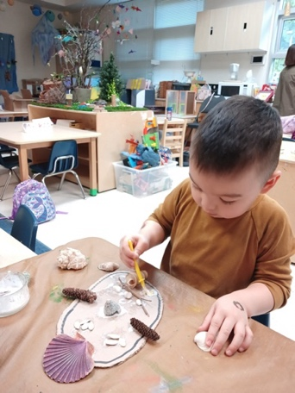
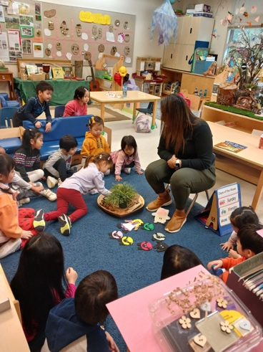 | 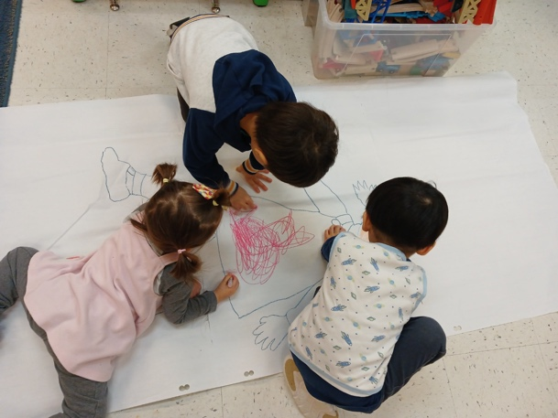
www.standrewkimecec.com

